MobFox Unity plugin

1. The MobFoxUnityPluginDistributables.zip contains all the files you will need.
Extract it’s content into a temporary directory.

2. In your Unity project, create a folder Assets/Plugin/iOS

Copy the following files from Plugins/iOS directory into that directory:

MobFoxUnityPlugin.mm
MobFoxUnityPlugin.h
MobFoxSDKCore.bundle
MobFoxSDKCore.framework

3. In your Unity project, create a folder Assets/Plugin/Android

Copy the following from Plugins/Android into that directory:

AndroidManifest.xml file
libs directory (and content)
res directory (and content)

4. In your Unity project, create a folder Assets/Scripts

Copy the following file from Scripts directory into that directory:

MobFox.cs
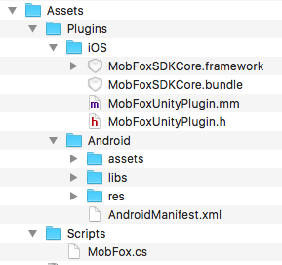

5. In your Unity project, create a game object called MobFoxObject. Attach the MobFox script to it.

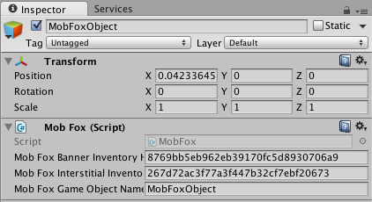

6. Fill the ‘Mob Fox Banner Inventory Hash’ field with your MobFox hash id for banners.

7. Fill the ‘Mob Fox Interstitial Inventory Hash’ field with your MobFox hash id for interstitials.

8. Fill the ‘Mob Fox Game Object Name’ field with the name of the game object if you use one other
than ‘MobFoxObject’.

9. Now you can use MobFox.ShowMobFoxBanner to display a banner ad.
You can use MobFox.CreateAndShowMobFoxInterstitial to display an interstitial ad.

New: You can call MobFox.ShowMobFoxSmartBanner to display a smart banner (full width, height 50 / 90).

New: If you want to first load the interstitial, and then show it any time you want (not in the callback) -
First call MobFox.CreateMobFoxInterstitial, you will get the interstitialReady callback when it is ready,
then call MobFox.ShowMobFoxInterstitial to show the interstitial.

Inside the MobFox script you can find the callback functions you can use to handle events related to the
banner ads (bannerReady, bannerError, bannerClosed, bannerClicked, bannerFinished) or interstitial
ads (interstitialReady, interstitialError, interstitialClosed, interstitialClicked, interstitialFinished).

You can also change the location and dimensions of banner ads by altering the parameters passed
in ShowMobFoxBanner_iPhone or ShowMobFoxBanner_Android (0, 0, 320, 50) are the default.

By default, use of location info is disabled. To enable it, you can call MobFox.SetUseLocation(true).

